**PROJECT REPORT ON**

**Attendance Management System**

Submitted in Partial Fulfillment of the Requirement

For the Award of Degree Bachelor of Computer Applications

**(Session 2016-2019)**



UTD Bhopal

**Guided By- Submitted By-**

**Prof. Dr.Sunita Dwivedi Disha Musre**

**Enrollment No- AP140999024**

**Satyam Jain**

**Enrollment No- AP140999020**

**BCA -6th SEM**

**Submitted To:**

**Makhanlal Chaturvedi**

**National University of Journalism & Communication, Bhopal**

# Acknowledgement

I would like to acknowledge and feel great pleasure to express my deepest gratitude and respect towards my internal project guide **Prof Dr. Sunita Dwivedi Mam**, for her valuable support and guidance. He guided me throughout the process from conception and till the completion of this project.

I would also like to express my gratitude to respect my faculties **Dr. Manish Maheshwari** (H.O.D Computer Department)**,** **Dr. Anurag Seetha, Dr. Sunita Dwivedi,** **Mr. Ravi Mohan Sharma,** and **Mr. Manoj Pachariya** for time to time valuable suggestion.

I am Indebted to my external guide **Mrs Priyanka Aasthana Mam , Mr.Aalok Aasthana Sir , Sandeep Gupta Sir** **.** Whose stimulating interest and preserving effort inspired me to complete my project.

**Satyam Jain**

**Disha Musre**

**BCA 2016-2019**

# Certificate

This is to certify that this Minor Project entitled “**Attendance Management System**” submitted in partial fulfilment of the degree of BACHELOR IN COMPUTER APPLICATION to the Makhanlal Chaturvedi National University of Journalism & Communication, Bhopal through UTD Bhopal, done by Miss.  **Disha Musre**, **Satyam jain** , **BCA(2016-2019)** is an is an authentic work carried out by her at UTD, MCRPV(Bhopal) under my guidance. The matter embodied in this project work has not been submitted earlier for award of any degree or diploma to the best of my knowledge and belief.

**Signature of the students Signature of the Guide**

**(Disha Musre) (Dr.Sunita Mam)**

**Signature of the students**

**(Satyam Jain)**

# Self-Certificate

This is to certify that the Minor Project Report entitled “**Attendance Management System**” is done by me is an authentic work carried out for the partial fulfilment of the requirements for the award of the degree of **Bachelor in Computer Application** under the guidance of **Dr.Sunita Dwivedi (Professor of Computer Department, MCRPV Bhopal)**. The matter embodied in this project work has not been submitted earlier for award of any degree or diploma to the best of my knowledge and belief.

**Signature of the student**

**Disha Musre**

**Enrollment No-AP140999024**

**Satyam Jain**

**Enrollment No-AP140999020**

**BCA(2016-2019)**

# Declaration

This is to certify that the work presented in the project entitled **“Attendance Management System”** in partial fulfilment of the requirement for the award of Degreeof **Bachelor of Application, Computer Department, MCNUJC Bhopal**, is an authentic work carried out under my supervision and guidance.

To the best of my knowledge, the content of this project does not form a basis for the award of any previous Degree to anyone else.

Date ……………. **Dr. Manish Maheswari**

**(HOD Computer Department)**

# Table of Contents

Acknowledgement 2

Certificate 3

Self-Certificate 4

Declaration 5

Table of Contents 6

Chapter 1 8

Introduction 8

Existing System- 8

Proposed System- 8

Problem Specification- 9

Chapter 2 10

Background Study 10

2.1 Description of previous- 10

2.2 Comparison of previous work- 10

2.3 Objective and scope of work- 11

Chapter 3 12

Technology Used 12

3.1 Automated Merchandise Distribution System- 12

3.2 Html5 and Css3- 13

3.3 Bootstrap- 15

3.4 PHP- 16

3.5 MySQL- 18

3.6 Ajax- 20

3.7 Json- 21

3.8 jQuery- 22

Chapter 4 23

System Analysis 23

4.1 Details of Modules- 23

4.2 Feasibility Study- 24

4.2.1 Technical Feasibility: 24

4.2.2 Economic Feasibility: 24

4.2.3 Behavioural / Operational Feasibility: 25

Chapter 5 26

Software & Hardware Requirement Specification 26

5.1 Introduction- 26

5.2 Hardware Specification- 26

5.3 Software Specification- 27

Chapter 6 28

System Design 28

6.1 Definition- 28

6.1.1 Output Design: 28

6.1.2 Input Design- 29

6.1.3 Logical Design- 29

6.2 Flow Diagrams- 30

6.2.1 Flow Diagram for Administrator Role- 31

6.2.2 Flow Diagram of User Role- 32

6.3 ER Diagram- 33

6.4 Implementation Code- 34

Chapter 7 51

Implementation & Result Analysis 51

7.1 High Level Diagram- 51

7.2 Low Level Diagram- 58

7.3 Result Analysis- 60

7.4 Conclusion- 60

Chapter 8 61

Future Work 61

Chapter 9 62

Conclusion 62

Chapter 10 63

Company Profile 63

Bibliography 65

# Chapter 1

## Introduction

“Attendance Management System” is software developed for maintaining the attendance of the student on the daily basis in the collage. Here the staffs, who are handling the subjects, will be responsible to mark the attendance of the students. Each staff will be given with a separate username and password based on the subject they handle. An accurate report based on the student attendance is generated here. This system will also help in evaluating attendance eligibility criteria of a student. Report of the student’s attendance on weekly and monthly basis is generated.

### Existing System-

The Existing system is a manual entry for the students. Here the attendance will be carried out in the hand written registers. It will be a tedious job to maintain the record for the user. The human effort is more here. The retrieval of the information is not as easy as the records are maintained in the hand written registers .This application requires correct feed on input into the respective field. Suppose the wrong inputs are entered, the application resist to work. so the user find it difficult to use.

### Proposed System-

To overcome the drawbacks of the existing system, the proposed system has been evolved. This project aims to reduce the paper work and saving time to generate accurate results from the student’s attendance. The system provides with the best user interface . The efficient reports can be generated by using this proposed system. In this application data is more secured and can be accessed easily.

**Advantages of Proposed System**

 It is trouble-free to use.

It is a relatively fast approach to enter attendance

Is highly reliable, approximate result from user

Best user Interface

Efficient report

### Problem Specification-

* In present time we work manually for maintain records and manage the merchandise and distribution of merchandise in between the different department of organization.
* As a department request for merchandise they have written all the items in a bill format and then send it to merchandise department.
* If the requested items is not available in the merchandise they event don’t get the message or information about the shortage of that particular item.
* Department User again can generate request format and then again request for same item if available department gets it otherwise generate new request again.
* If the user want a no of quantity of requested item which is not available on the merchandise at that time they even don’t get message for not fulfill the quantity which they want.
* Merchandise Handler does not have information about the quantity of each and every item as they were not present in the Merchandise.

# 

# Chapter 2

## Background Study

### 2.3 Objective and scope of work-

Attendance management is significant to all organizations such as educational institutions. The proposed system offers the process of monitoring the attend students, it aims to help the teacher in the classroom. Since our system is modular and can extend effortlessly, the future work ambitions are

•to manage and record students presence electronically and directly without the need to list on paper so it will save time and effort.

•student‘s absences, printing report about absence percentages and students warnings for the specified period.

•The developed system easy to use and friendly that has an attractive and simple GUI.

•The system is working exciting and is ready to use to manage students attend for any department of the University, College or Institute.

**In future system may takes attendance by other methods such as:**

* Biometrics (fingerprint) technique
* Simplified Process with Automated Calculations like about the salary
* Tracking Employee information about there presence in the class
* Face recognition

# Chapter 3

## Technology Used

### 3.1 Attendance Management System-



Attendance Management System Application is used develop for managing the attendance of different courses running in departments of any educational organisation. This system includes several modules like user management, Department management, request management, merchandise management, purchase details etc.

Automated means to replace the manual operations with computer procedures and other machines. Automation is aimed at increasing productivity, manufacturing prowess. It also reduces costs, labour and eliminates human error.

Showing comparison of Manual process and automated process of Merchandise Distribution System:

|  |  |
| --- | --- |
| **Manual Attendance Management System** | **Attendance Management System Application** |
| Human process | Computerised Process |
| Chances of error generation while maintaining records | Chances of error or mistakes reduces |
| Low Security | Higher Security |
| Slow as human labour involved | Faster due to computer based automation |
| Tough to manage register for long time | Easy to manage register for long time |

This application has good appearance and is very easy to operate. It saves our time and money. This project provides a lot of features to manage in a very well manner. This project contains a lot of advance modules which makes the back end system very powerful.

### 3.4 JAVA-



Initially, Java was developed by Sun Microsystems. James Gosling, Mike Sheridan, and Patrick Naughton initiated the Java language project. Now Sun Microsystems has been acquired by Oracle.

* The main feature is platform independent i.e. “Write once and run anywhere”. Java code can be compiled as bytecode and it can be run in any environment with JVM.
* Java supports multithreading and it makes thread programming easy.
* Java supports a distributed environment .
* Java binary code is independent of any hardware or software architecture. Hence, it has an architecture neutral feature.
* Java bytecode can be carried easily, thus Java is portable.
* Java Syntax is C-Like.

Five important characteristics make JAVA's practical nature possible −

Simplicity

Efficiency

Security

Familiarity

Portability

### 3.5 MySQL-



MySQL is a Relational Database Management System (RDBMS).

RDBMS means R--DB--MS.

- DB stands for Database, a repository for the information store.

1. The data in a database is organized into tables, and each table is organized into rows and columns.
2. Each row in a table is called a record. A record may contains several pieces (called fields) of information, and each column in a table is known as a field.
3. Features of MySQL

**1. Speed:** Of course, the speed at which a server side program runs depends primarily on the server hardware. Given that the server hardware is optimal, MySQL runs very fast. It supports clustered servers for demanding applications.

**2. Ease of use:** MySQL is a high-performance, relatively simple database system. From the beginning, MySQL has typically been configured, monitored, and managed from the command line. However, several MySQL graphical interfaces are available as described below:

1. MySQL Administrator: This tool makes it possible for administrators to set up, evaluate, and tune their MySQL database server. This is intended as a replacement for MySQL admin.
2. MySQL Query Browser: Provides database developers and operators with a graphical database operation interface. It is especially useful for seeing multiple query plans and result sets in a single user interface.
3. Configuration Wizard: Administrators can choose from a predefined list of optimal settings, or create their own.
4. MySQL System Tray: Provides Windows-based administrators a single view of their MySQL instance, including the ability to start and stop their database servers.

**3. Cost:** MySQL is available free of cost. MySQL  is a "Open Source" database. MySQL is part of LAMP (Linux, Apache, MySQL, PHP / Perl / Python) environment, a fast growing open source enterprise software stack. More and more companies are using LAMP as an alternative to expensive proprietary software stacks because of its lower cost, reliability, and documentation.

**4. Query Language Support:** MySQL understands standards based SQL (Structured Query Language).

**5. Capability:** Many clients can connect to the server at the same time. Clients can use multiple databases simultaneously. You can  access MySQL using several interfaces such as command-line clients, Web browsers.

**6. Connectivity and security:** MySQL is fully networked, and database can be accessed from anywhere on the Internet, so you can share your data with anyone, anywhere. The connectivity could be achieved with Windows programs by using ODBC drivers. By using the ODBC connector to MySQL, any ODBC-aware client application (for example, Microsoft Office, report writers, Visual Basic) can connect to MySQL.

**7. Portability:**MySQL runs on many varieties of UNIX, as well as on other non-UNIX systems, such as Windows and OS/2. MySQL runs on hardware from home PCs to high-end server. MySQL can be installed on Windows XP, Windows Server 2003, Red Hat Fedora Linux, Debian Linux, and others.

MySQL Tools

1. A SQL server: This is an engine which provides access to your databases.

2. Client programs for accessing the server: A program allows you to enter queries directly and view results.

3. A client library for writing your own programs: You can write your own programs into the client library using C.

# 

# Chapter 4

## System Analysis

System analysis is the act, process, or profession of studying an activity (such as a procedure, a business, or a physiological function) typically by mathematical means in order to define its goals or purposes and to discover operations .and procedures for accomplishing them most efficiently.

### 4.1 **Details of Modules-**

1. Users
2. Faculty
3. Admin

**1. Users Module**- The user module is user which is an student to see there attendance.

**2.Faculty Module** – This Second module is handled by faculty or an operator. user has a right of making daily attendance and generating report.

**3. Admin Module** - This module admin which has right to create new entry of new batch. Any entry of new faculty, updation in subjects if necessary, and sending notice.

### 4.2 Feasibility Study-

A feasibility analysis usually involves a thorough assessment of the operational (need), financial and technical aspects of a proposal. Feasibility study is the test of the system proposal made to identify whether the user needs may be satisfied using the current software and hardware technologies, whether the system will be cost effective from a business point of view and whether it can be developed with the given budgetary constraints. A feasibility study should be relatively cheap and done at the earliest possible time. Depending on the study, the decision is made whether to go ahead with a more detailed analysis.

When a new project is proposed, it normally goes through feasibility assessment. Feasibility study is carried out to determine whether the proposed system is possible to develop with available resources and what should be the cost consideration. Facts considered in the feasibility analysis were

* Technical Feasibility
* Economic Feasibility
* Behavioral Feasibility

### 4.2.1 Technical Feasibility:

Technical feasibility includes whether the technology is available in the market for development and its availability. The assessment of technical feasibility must be based on an outline design of system requirements in terms of input, output, files, programs and procedures. This can be qualified in terms of volumes of data, trends, frequency of updating, cycles of activity etc., in order to give an introduction of technical system. Considering our project it is technical feasible. Technical evaluation must also assess whether the existing systems can be upgraded to use the new technology and whether the organization has the expertise to use it.

### 4.2.2 Economic Feasibility:

Development of this application is highly economically feasible. It is cost effective in the sense that has eliminated the paper work completely. The system is also time effective because the calculations are automated as per the user requirement. This feasibility study present tangible and intangible benefits from the project by comparing the development and operational cost . The technique of cost benefit analysis is often used as a basis for assessing economic feasibility.

Thus feasibility study should centre along the following points:

* Improvement resulting over the existing method in terms of accuracy, timeliness.
* Cost comparison
* Estimate on the life expectancy of the hardware.
* Overall objective.

Our project is economically feasible. It does not require much cost to be involved in the overall process. The overall objective is in easing out the recruitment processes

### 4.2.3 Behavioural / Operational Feasibility:

The system working is quite easy to use and learn due to its simple but attractive interface. User requires no special training for operating the system. Technical performance include issues such as determining whether the system can provide the right information for the Department personnel student details, and whether the system can be organized so that it always delivers this information at the right place and on time . Acceptance revolves around the current system and its personnel. This analysis involves how it will work when it is installed and the assessment of political and managerial environment in which it is implemented.

# Chapter 5

## Software & Hardware Requirement Specification

### 5.1 Introduction-

A Software requirements specification (SRS), a requirements specification for a [software system](http://en.wikipedia.org/wiki/Software_system), is a description of the behavior of a system to be developed and may include a set of [use cases](http://en.wikipedia.org/wiki/Use_case) that describe interactions the users will have with the software.

The Hardware Specification mainly describes the requirements posed on the hardware element and specifies the connected interfaces. In addition, requirements and interfaces will be refined and allocated to lower hardware elements.

### 5.2 Hardware Specification-

Computer hardware specifications are technical descriptions of the computer's components and capabilities. Processor speed, model and manufacturer. Processor speed is typically indicated in gigahertz (GHz). The higher the number, the faster the computer. Random Access Memory (RAM), This is typically indicated in gigabytes (GB). The more RAM in a computer the more it can do simultaneously. Hard disk (sometimes called ROM) space.  This is typically indicated in gigabytes (GB) and refers generally to the amount of information (like documents, music and other data) your computer can hold.

**Type Min. Requirement**

* System : - Core i5
* Hard Disk : - Minimum
* Monitor : - SVGA
* Ram : - 2GB(32-Bit), 4 GB(64-Bit)
* Keyboard :- Qwerty Keyboard

### 5.3 Software Specification-

Software specification is defining software resource requirements and prerequisites that need to be installed on a computer to provide optimal functioning of an application. These requirements or prerequisites are generally not included in the software installation package and need to be installed separately before the software is installed.

* Environment :- Netbeans IDE
* OS Environment :- Windows 10
* Language :- JAVA
* Database :- MYSQL

# Chapter 6

## System Design

### 6.1 Definition-

The most creative and challenging face of the system development is System Design. It provides the understanding and procedural details necessary for the logical and physical stages of development. In designing a new system, the system analyst must have a clear understanding of the objectives, which the design is aiming to fulfill. The first step is to determine how the output is to be produced and in what format. Second, input data and master files have to be designed to meet the requirements of the proposed output. The operational phases are handled through program construction and testing.

Design of the system can be defined as a process of applying various techniques and principles for the purpose of defining a device, a process or a system in sufficient detail to permit its physical realization. Thus system design is a solution to “how to” approach to the creation of a new system. This important phase provides the understanding and the procedural details necessary for implementing the system recommended in the feasibility study. The design step provides a data design, architectural design, and a procedural design.

### 6.1.1 Output Design:

In the output design, the emphasis is on producing a hard copy of the information requested or displaying the output on the CRT screen in a predetermined format. Two of the most output media today are printers and the screen. Most users now access their reports from either a hard copy or screen display. Computer’s output is the most important and direct source of information to the user, efficient, logical, output design should improve the systems relations with the user and help in decision-making.

As the outputs are the most important source of information to the user, better design should improve the systems relations and also should help in decision-making. The output device’s capability, print quality, response time requirements etc. should also be considered, form design elaborates the way the output is presented and layout available for capturing information. It’s very helpful to produce the clear, accurate and speedy information for end users.

### 6.1.2 Input Design-

In the input design, user-originated inputs are converted into a computer-based system format. It also includes determining the record media, method of input, speed of capture and entry on to the screen. Online data entry accepts commands and data through a keyboard. The major approach to input design is the menu and the prompt design. In each alternative, the user’s options are predefined. The data flow diagram indicates logical data flow, data stores, source and destination. Input data are collected and organized into a group of similar data once identified input media are selected for processing.

In this application, importance is given to develop Graphical User Interface (GUI), which is an important factor in developing efficient and user friendly software. For inputting user data, attractive forms are designed Also the important input format is designed in such a way that accidental errors are avoided. The user has to input only just the minimum data required, which also helps in avoiding the errors that the users may make. Accurate designing of the input format is very important in developing efficient software. The goal of input design is to make entry as easy, logical and free from errors.

### 6.1.3 Logical Design-

Logical data design is about the logically implied data. Each and every data in the form can be designed in such a manner to understand the meaning. Logical data designing should give a clear understanding & idea about the related data used to construct a form.

### 6.2 Flow Diagrams-

Login Type = “Department User”

* New Request
* Request History

Login Form

Login Type=“Admin”

* Department Mgt
* User Mgt
* Merchandise Mgt
* Purchase Mgt
* Request Mgt

### 6.2.1 Flow Diagram for Administrator Role-

Add / Edit / Delete

Admin

Add /Edit/Delete

Order/ View

Database

View/ Approved

### **6.2.2 Flow Diagram of User Role**-

Order / View

Department

User

Database

View / Accept

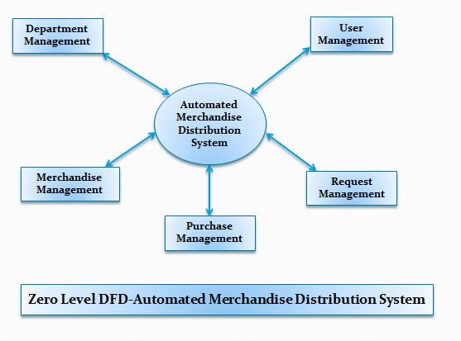

### 6.3 ER Diagram-

M-user

Status

Name

Dept

Role

Email

Password

Uid

M-dept

Did

Name

Uid

M-purchase

Pid

Sid

Qty

Price

Date

Status

Category

Name

Sid

Status

Date

Dept

Items

Rid

M-cat

Scid

Cname

M-items

M-rqst

### 6.4 Implementation Code-

#### Login.php –

##### <?php

##### $no_visible_elements = true;

##### include('header.php'); ?>

##### <div class="row">

##### <div class="col-md-12 center login-header">

##### <h2>Welcome to Automated Merchandise Distribution System</h2>

##### </div>

##### <!--/span-->

##### </div><!--/row-->

##### <div class="row">

##### <div class="well col-md-5 center login-box">

##### <div class="alert alert-info">

##### Please login with your Username and Password.

##### </div>

##### <form class="form-horizontal" action="logincheck.php" method="post">

##### <fieldset>

##### <div class="input-group input-group-lg">

##### <span class="input-group-addon"><i class="glyphicon glyphicon-user red"></i></span>

##### <input type="text" name="name"class="form-control" placeholder="Username">

##### </div>

##### <div class="clearfix"></div><br>

##### <div class="input-group input-group-lg">

##### <span class="input-group-addon"><i class="glyphicon glyphicon-lock red"></i></span>

##### <input type="password" name="pwd" class="form-control" placeholder="Password"></div>

##### <div class="clearfix"></div>

##### <div class="input-prepend">

##### <label class="remember" for="remember"><input type="checkbox" id="remember"> Remember me</label>

##### </div>

##### <div class="clearfix"></div>

##### <p class="center col-md-5">

##### <button type="submit" class="btn btn-primary"> Login</button>

##### </p>

##### </fieldset>

##### </form>

##### </div>

##### <!--/span-->

##### </div><!--/row-->

##### <?php require('footer.php'); ?>

#### Logincheck.php-

##### <?php

##### Session_start();

##### include ("include/connection.php");

##### $sql = "SELECT * from stck_user where upper(name) ='".strtoupper($_POST["name"]) ."' and password ='".$_POST["pwd"]."'";

##### $result = $conn->query($sql);

##### //echo $result;

##### if ($result->num_rows > 0)

##### {

##### // output data of each row

##### $row = $result->fetch_assoc();

##### //echo " - username: " . $row["username"]. "password : " . $row["password"]. "<br>";

##### $_SESSION["login"]="true";

##### $_SESSION["name"]=$row["name"];

##### $_SESSION["email"]=$row["email"];

##### $_SESSION["role"]=$row["role"];

##### $_SESSION["did"]=$row["dept"];

##### $_SESSION["stat"]=$row["status"];

##### $_SESSION["uid"]=$row["uid"];

##### $_SESSION["dept"]=$row["name"];

##### if($_SESSION["role"]=="Admin")

##### {

##### header("location:dashboard.php");

##### }

##### else

##### {

##### header("location:dashboard_user.php");

##### }

##### }

##### else

##### {

##### echo "Invalid Username Password";

##### }

##### ?>

#### Merchandise.php –

##### <?php session_start();

##### require('header.php');

##### include ("include/connection.php");?>

##### <script>

##### $(document).ready(function(e)

##### {

##### $("#catnm").change(function(e)

##### {

##### //alert($(this).val());

##### });

##### var status="add";

##### //var did=0;

##### $("#add").click(function(e)

##### {

##### //console.log("add clicked");

##### var formdata=$("#newstock").serialize();

##### //alert(formdata);

##### $.post("stockmgt.php?opt="+status,formdata,function(data)

##### {

##### //console.log(data);

##### if(data.search("Error")==-1)

##### {

##### showNotification("Stock Inserted successfully");

##### }

##### else

##### {

##### showNotification("There is some problem with data","error");

##### }

##### });

##### });

##### //new dept

##### $(".del").click(function(e)

##### {

##### //console.log("add clicked");

##### var sid=$(this).data("sid");

##### $.post("stockmgt.php",{opt:"del","sid":sid},function(data)

##### {

##### 

##### if(data.search("Error")==-1)

##### {

##### showNotification("Stock Deleted Succesfully");

##### }

##### else

##### {

##### showNotification("There is some problem with data","error");

##### }

##### });

##### });

##### $(".update").click(function(e)

##### {

##### $(".modal-title").text("Stock To be edited");

##### var sid=$(this).data("sid");

##### 

##### $.post("stockmgt.php",{opt:"fetch","sid":sid},function(data)

##### {

##### //console.log(data);

##### var arr=data.split(";");

##### $("#newstock").val(arr[1]);

##### $("#sid").val(arr[0]);

##### 

##### status="update";

##### $("#myModal").modal("show");

##### 

##### /*if(data=="true")

##### {

##### showNotification("success");

##### }

##### else

##### {

##### showNotification("There is some problem with data","error");

##### }

##### */ });

##### });

##### });

##### </script>

##### <div>

##### <ul class="breadcrumb">

##### <li>

##### <a href="#">Home</a>

##### </li>

##### <li>

##### <a href="#">Merchandise Item</a>

##### </li>

##### </ul>

##### </div>

##### <div class="table-responsive">

##### <table class="table grid">

##### <tbody>

##### <tr>

##### <td colspan="12">

##### <button data-toggle="modal" data-target="#myModal" type="button" class="btn btn-primary"><i class="glyphicon glyphicon-plus-sign" > </i> Add</button>

##### <button data-toggle="modal" data-target="#myModal1" type="button" class="btn btn-primary"><i class="glyphicon glyphicon-refresh"> </i> Refresh</button>

##### <!--<button type="button" class="btn btn-primary"><i class="glyphicon glyphicon-arrow-up"> </i> Update</button>-->

##### </td>

##### </tr>

##### </tbody>

##### </table>

##### </div>

##### <div class="row">

##### <div class="box col-md-12">

##### <div class="box-inner">

##### <div class="box-header well" data-original-title="">

##### <h2><i class="glyphicon shopping-cart"></i>Merchandise Data</h2>

##### </div>

##### <div class="box-content">

##### <table class="table table-striped table-bordered bootstrap-datatable datatable responsive">

##### <thead>

##### <tr>

##### <th>Merchandise Id</th>

##### <th>Item Name</th>

##### <th>Category</th>

##### <th>Status</th>

##### <th>Actions</th>

##### </tr>

##### </thead>

##### <tbody>

##### <?php

##### $sql = "SELECT stck_item.name,stck_item.sid,stck_item.status,stck_cat.cname

##### FROM stck_cat INNER JOIN stck_item ON stck_cat.scid=stck_item.scid";

##### $result = $conn->query($sql);

##### // output data of each row

##### while($row = $result->fetch_assoc())

##### {

##### echo "<td>". $row["sid"]."</td>";

##### echo "<td>". $row["name"]."</td>";

##### echo "<td>". $row["cname"]."</td>";

##### echo "<td>". $row["status"]."</td>";

##### echo "<td><a data-sid ='$row[sid]' class='btn btn-info btn-xs update' href='#'><i class='glyphicon glyphicon-edit icon-white'></i></a>

##### <a data-sid ='$row[sid]' class='btn btn-danger btn-xs del' href='#'><i class='glyphicon glyphicon-trash icon-white'></i></a></td>";

##### echo "</tr>";

##### }

##### ?>

##### </tbody>

##### </table>

##### </div>

##### </div>

##### </div>

##### <!--/span-->

##### <div class="modal fade" id="myModal">

##### <div class="modal-dialog">

##### <div class="modal-content">

##### <!-- Modal Header -->

##### <div class="modal-header">

##### <h4 class="modal-title">New Stock Item</h4>

##### </div>

##### <!-- Modal body -->

##### <div class="modal-body">

##### <form id="newstock">

##### <div class="form-group">

##### <div class="row">

##### <div class="col-sm-6"><label for="itnm" >Item Name :</label>

##### <input type="textbox" class="form-control" id="itnm" name="itnm" placeholder="Enter Item Name"></div>

##### <div class="col-sm-6"><label for="catnm">Category :</label>

##### <select class="form-control" name="catnm" id="catnm">;

##### <?php

##### $sql = "SELECT * FROM stck_cat";

##### $result = $conn->query($sql);

##### // output data of each row

##### while($row = $result->fetch_assoc())

##### {

##### echo "<option value='". $row['scid'] ."'>" .$row['cname'] ."</option>";

##### }

##### ?>

##### </select>

##### </div>

##### </div>

##### <div class="row">

##### <div class="col-lg-12">

##### &nbsp;

##### </div>

##### </div>

##### <input type="hidden" name="sid" id="sid" value="0">

##### <div class="row">

##### <div class="col-sm-12"><label for="status" >Status:</label>

##### <select class="form-control" name="status">

##### <option value='Active'>Active</option>

##### <option value='Deactive'>Deactive</option>

##### </select>

##### </div>

##### </div>

##### <div class="row">

##### <div class="col-lg-12">

##### &nbsp;

##### </div>

##### </div>

##### </form>

##### </div>

##### <div class="modal-footer">

##### <button type="button" id="add" class="btn btn-primary" data-dismiss="modal">Add</button>

##### <button type="button" class="btn btn-primary" data-dismiss="modal">Close</button>

##### </div>

##### </div>

##### </div>

##### </div>

##### </div><!--/row-->

##### <?php require('footer.php'); ?>

#### Rqstdetails.php-

##### <?php session_start();

##### require('header_user.php');

##### include ("include/connection.php");?>

##### <script>

##### $(document).ready(function(e) {

##### var status="add";

##### //var did=0;

##### 

##### $(".view").click(function(e) {

##### var rid=$(this).data("rid");

##### window.open("rqstdetail.php?rid="+rid);

##### });

##### $("#print").click(function(e) {

##### window.print("rqstdetail.php?rid="+rid);

##### });

##### });

##### </script>

##### <div>

##### <ul class="breadcrumb">

##### <li>

##### <a href="#">Home</a>

##### </li>

##### <li>

##### <a href="#">Histroy</a>

##### </li>

##### </ul>

##### </div>

##### <div class="table-responsive">

##### <table class="table grid">

##### <tbody>

##### <tr>

##### <td colspan="12">

##### 

##### </td>

##### </tr>

##### </tbody>

##### </table>

##### </div>

##### <div class="row">

##### <div class="box col-md-12">

##### <div class="box-inner">

##### <div class="box-header well" data-original-title="">

##### <h2><i class="glyphicon shopping-cart"></i>History Details</h2>

##### </div>

##### <div class="box-content">

##### <table class="table table-striped table-bordered bootstrap-datatable datatable responsive">

##### <thead>

##### <tr>

##### <th >Date</th>

##### <th >Status</th>

##### <th >Actions</th>

##### </tr>

##### </thead>

##### <tbody>

##### <?php

##### //$did=$_POST["did"];

##### $sql = "SELECT * FROM stck_rqst where did=$_SESSION[did]";

##### $result = $conn->query($sql);

##### // output data of each row

##### while($row = $result->fetch_assoc())

##### {

##### echo "<tr>";

##### echo "<td>". $row["date"]."</td>";

##### echo "<td>". $row["status"]."</td>";

##### echo "<td>

##### <button type='button' data-rid='$row[rid]' class='btn btn-primary view'><i class='glyphicon glyphicon-list icon-white'> </i> View Bill</button>

##### <button type='button' data-rid='$row[rid]' class='btn btn-primary print'><i class='glyphicon glyphicon glyphicon-print icon-white'> </i> Print</button></td>";

##### echo "</tr>";

##### }

##### ?>

##### </tbody>

##### </table>

##### </div>

##### </div>

##### </div>

##### <!--/span-->

##### </div><!--/row-->

##### <?php require('footer.php'); ?>

#### Viewdetails.php –

##### <?php session_start();

##### include ("include/connection.php");?>

##### <link id="bs-css" href="css/bootstrap-cerulean.min.css" rel="stylesheet">

##### <link href="css/charisma-app.css" rel="stylesheet">

##### <link href='bower_components/fullcalendar/dist/fullcalendar.css' rel='stylesheet'>

##### <link href='bower_components/fullcalendar/dist/fullcalendar.print.css' rel='stylesheet' media='print'>

##### <link href='bower_components/chosen/chosen.min.css' rel='stylesheet'>

##### <link href='bower_components/colorbox/example3/colorbox.css' rel='stylesheet'>

##### <link href='bower_components/responsive-tables/responsive-tables.css' rel='stylesheet'>

##### <link href='bower_components/bootstrap-tour/build/css/bootstrap-tour.min.css' rel='stylesheet'>

##### <link href='css/jquery.noty.css' rel='stylesheet'>

##### <link href='css/noty_theme_default.css' rel='stylesheet'>

##### <link href='css/elfinder.min.css' rel='stylesheet'>

##### <link href='css/elfinder.theme.css' rel='stylesheet'>

##### <link href='css/jquery.iphone.toggle.css' rel='stylesheet'>

##### <link href='css/uploadify.css' rel='stylesheet'>

##### <link href='css/animate.min.css' rel='stylesheet'>

##### <script>

##### $(document).ready(function(e) {

##### var did=$(this).data("did");

##### var date=$(this).data("date");

##### 

##### });

##### </script>

##### 

##### 

##### <div class="container">

##### <label>Department Name :</label>

##### <label>

##### <?php

##### //$did=$_REQUEST["did"];

##### //$dept=$_SESSION["did"];

##### $sql="SELECT a.*,b.* FROM stck_dept a LEFT JOIN stck_rqst b ON a.did =b.did where b.rid=$_GET[rid]";

##### $result = mysqli_query($conn,$sql);

##### while($row=mysqli_fetch_assoc($result))

##### {

##### echo $row['name'];

##### }

##### ?>

##### </label>

##### <br>

##### <label>Date of Request :</label>

##### <label>

##### <?php

##### //$date=$_REQUEST["date"];

##### $rid=$_REQUEST["rid"];

##### $sql = "SELECT date FROM stck_rqst WHERE rid=$rid";

##### $result = mysqli_query($conn,$sql);

##### while($row = mysqli_fetch_assoc($result))

##### {

##### 

##### echo $row['date'];

##### }?>

##### </label>

##### <br>

##### <table class="table table-striped table-bordered responsive">

##### <thead>

##### <tr>

##### <th>SNo.</th>

##### <th>Item Name</th>

##### <th>Quantity</th>

##### </tr>

##### </thead>

##### <tbody>

##### <tr>

##### </tr>

##### <?php

##### //$did=$_POST["did"];

##### //$date=$_POST["date"];

##### //$status=$_POST["status"];

##### $rid=$_REQUEST["rid"];

##### $sql = "SELECT * FROM stck_rqst where rid='$rid'";

##### $result = $conn->query($sql);

##### $row=mysqli_fetch_assoc($result);

##### $items=json_decode($row["items"]);

##### //print_R($row["items"]);

##### //echo $row["date"];

##### for($i=0;$i<count($items);$i++)

##### {

##### echo "<tr>";

##### echo "<td>".($i+1)."</td>";

##### $sql = "SELECT * from stck_item where sid=".$items[$i]->stck;

##### $result = $conn->query($sql);

##### $row1=mysqli_fetch_assoc($result);

##### echo "<td>$row1[name]</td>";

##### echo "<td>".$items[$i]->qty."</td>";

##### /*echo "<td>

##### <a data-rid='$row[rid]' class='btn btn-info btn-xs update' href='#'><i class='glyphicon glyphicon-edit icon-white'></i></a></td>";*/

##### echo "</tr>";

##### }

##### ?>

##### </tbody>

##### </table>

##### </div>

##### </div>

##### </div>

##### </div>

# 

# Chapter 7

## Implementation & Result Analysis

### 7.1 High Level Diagram-

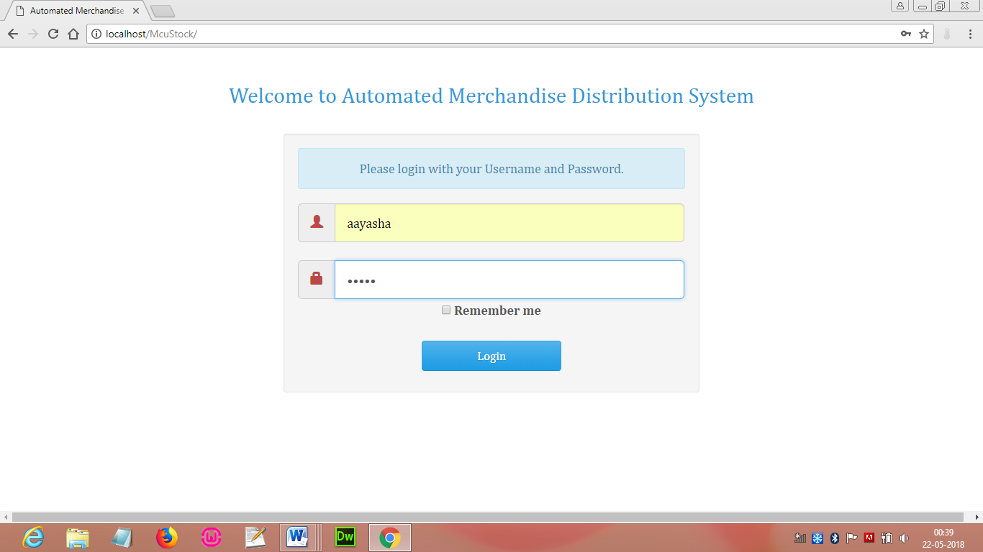

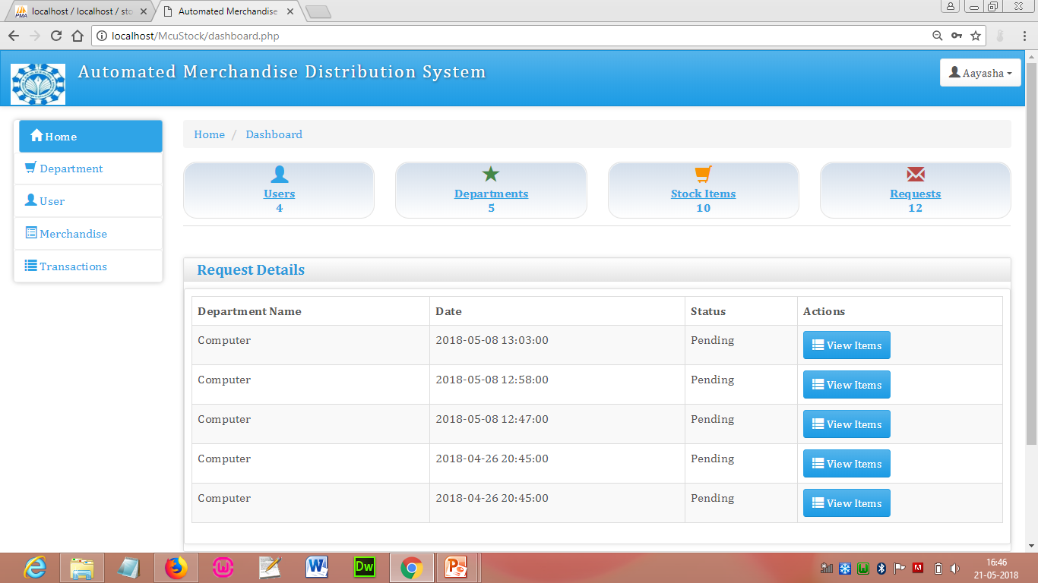

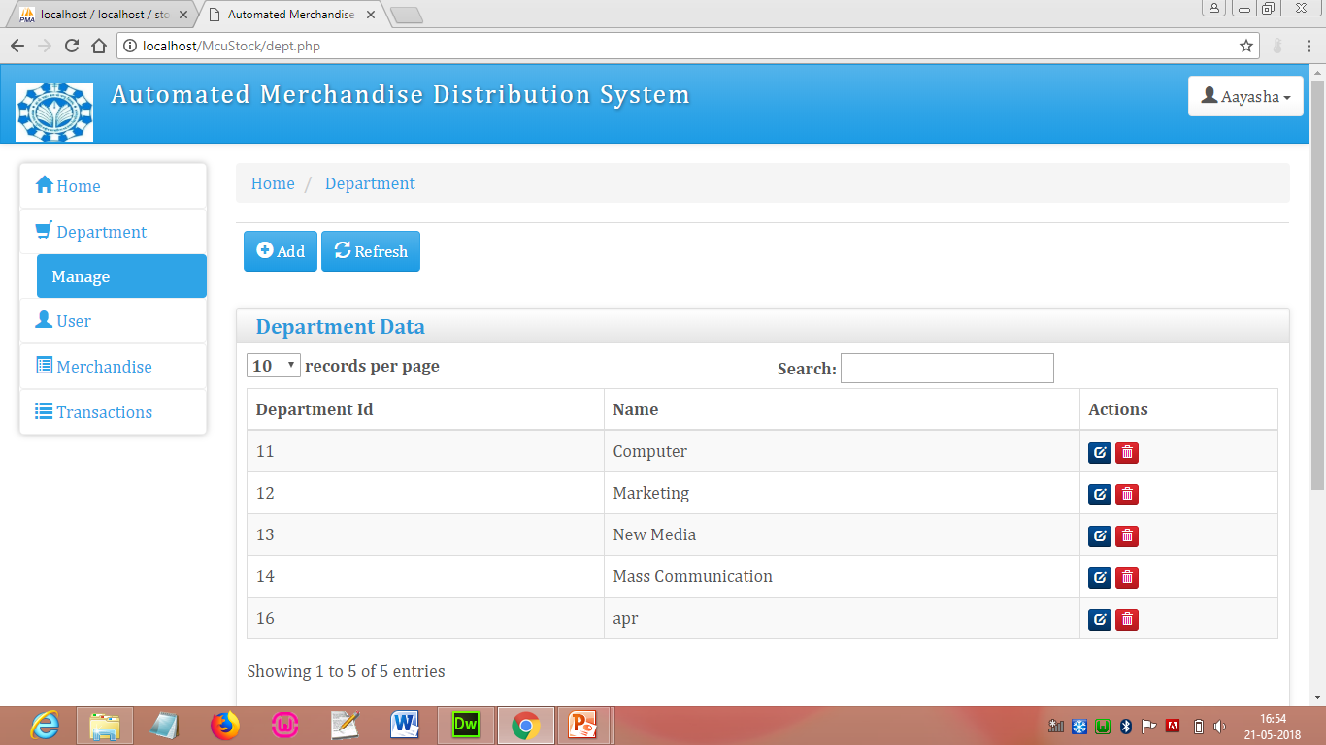

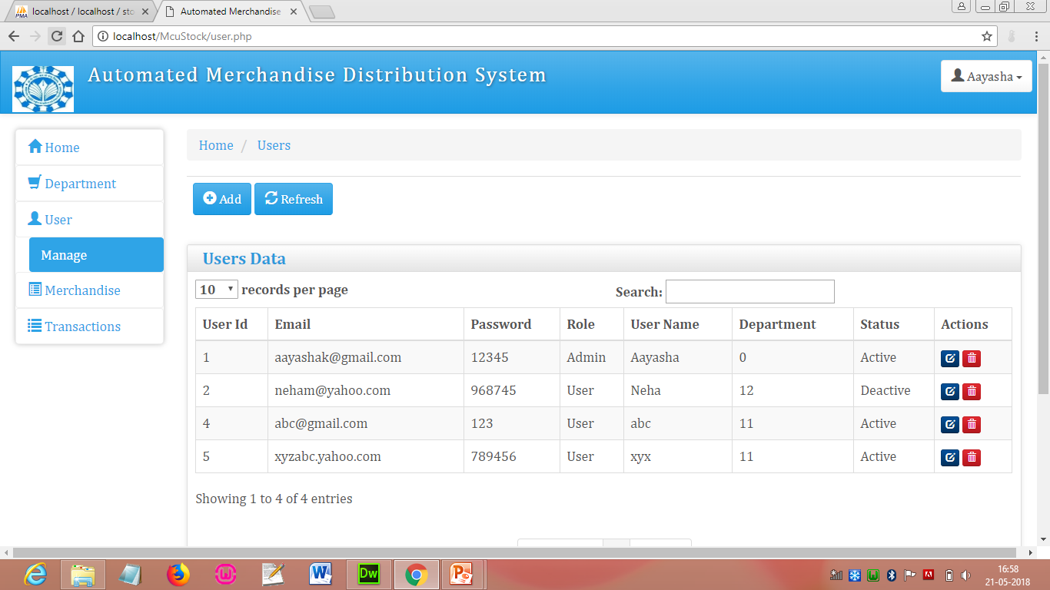

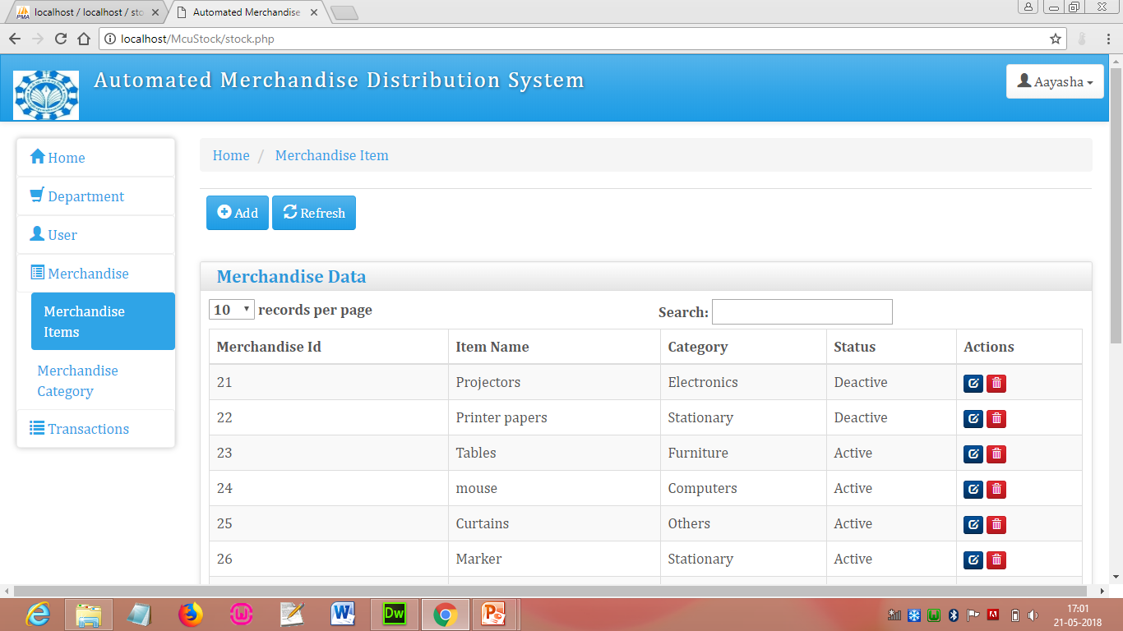

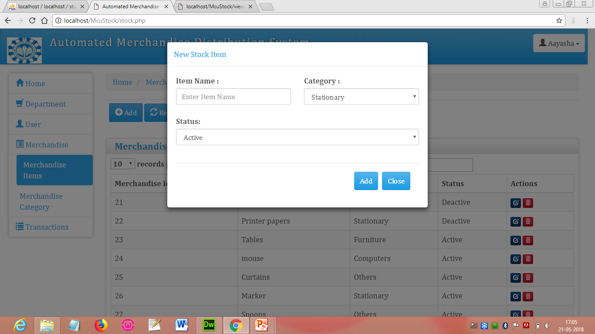

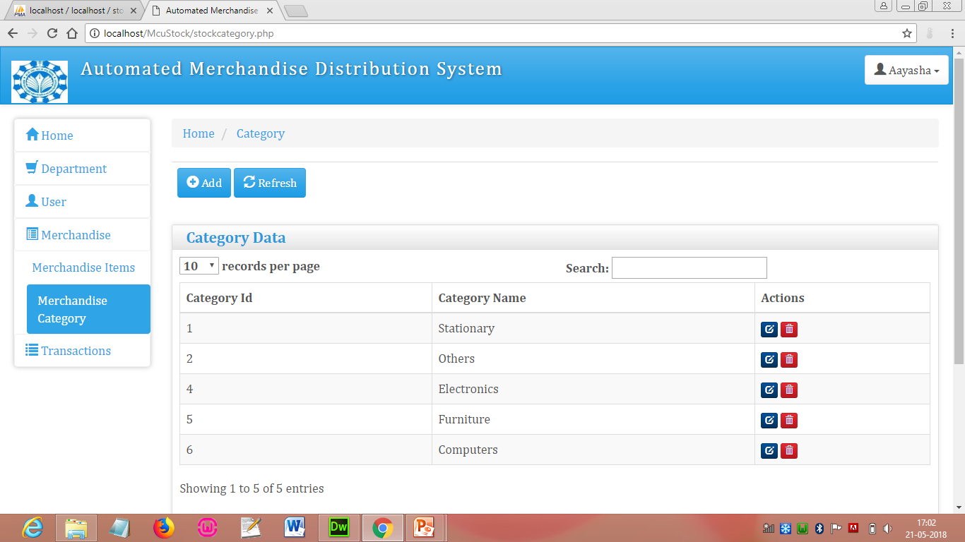

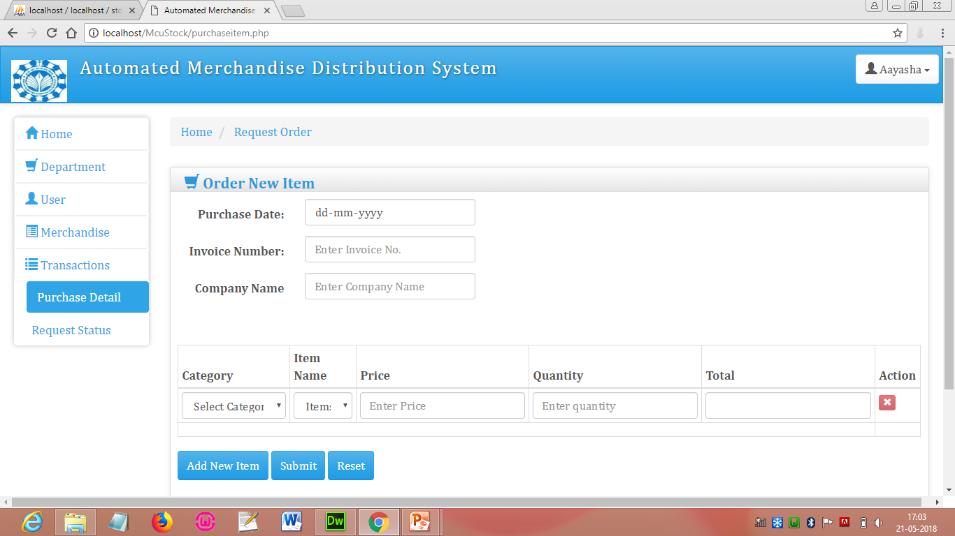

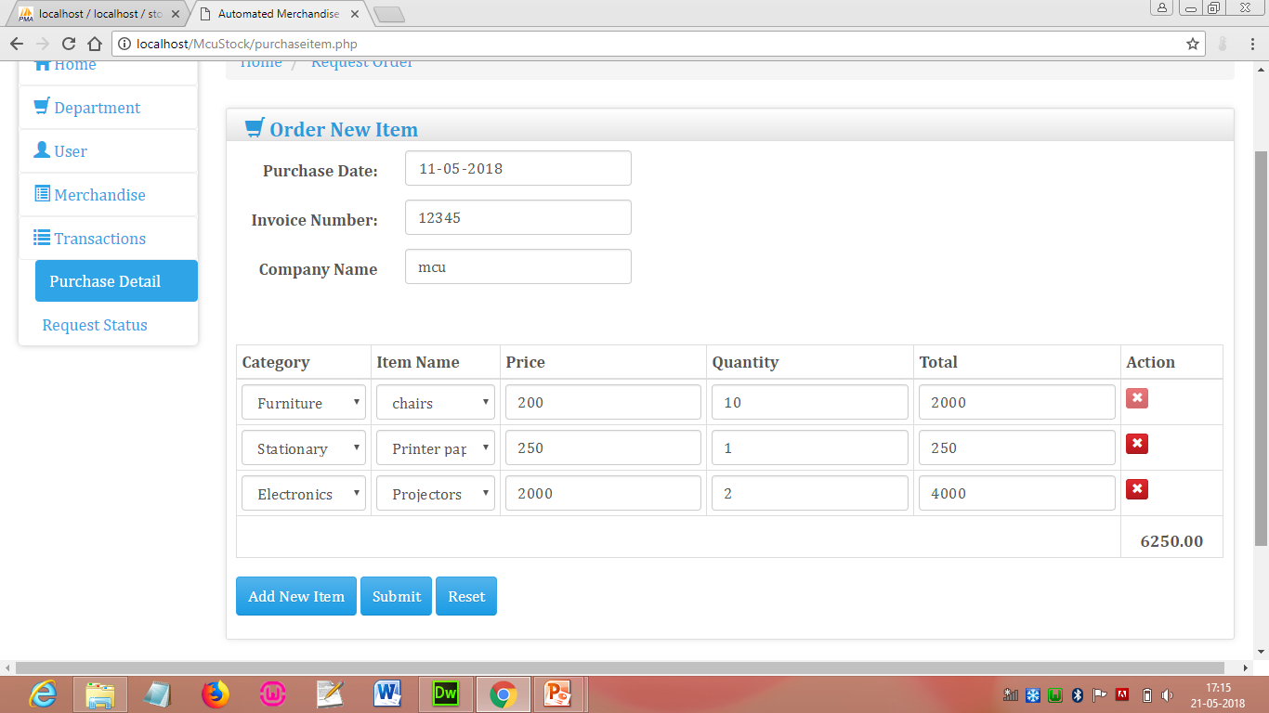

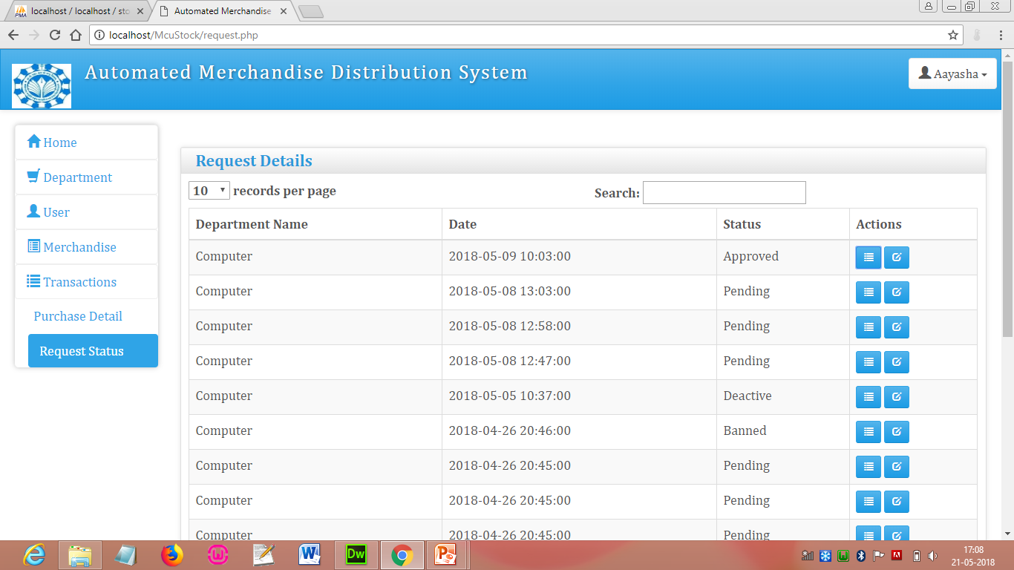

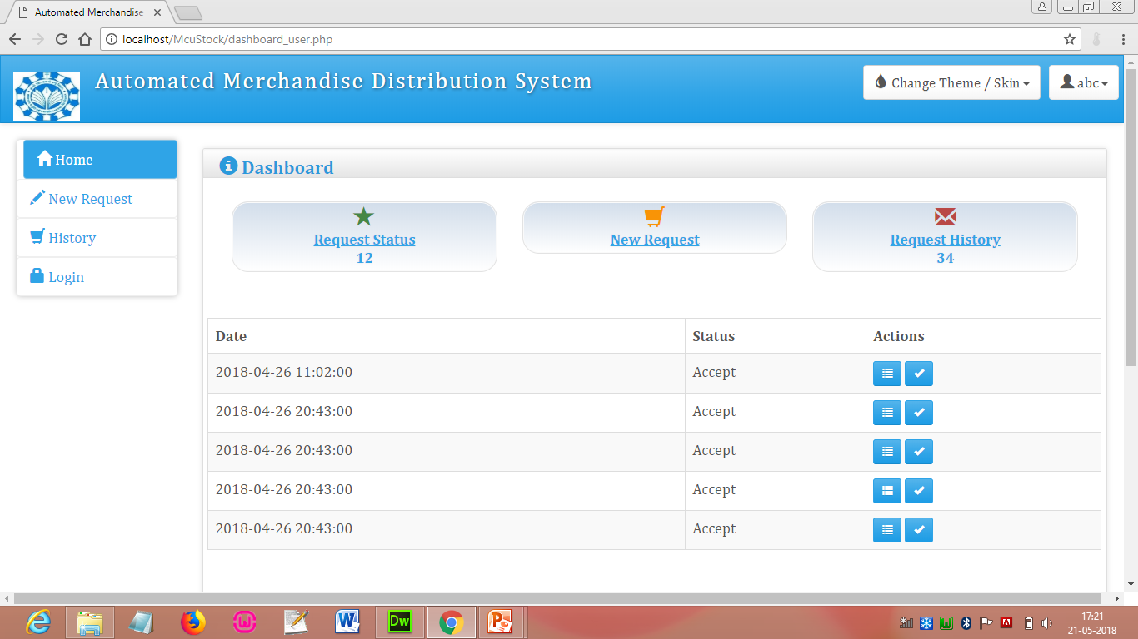

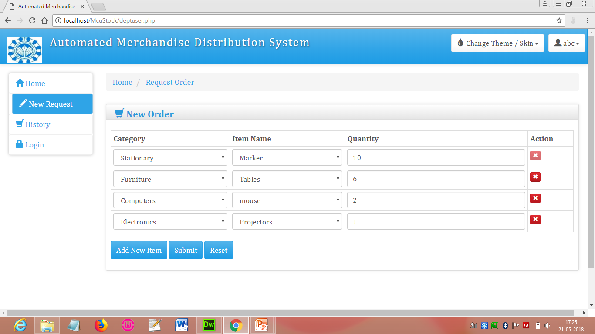

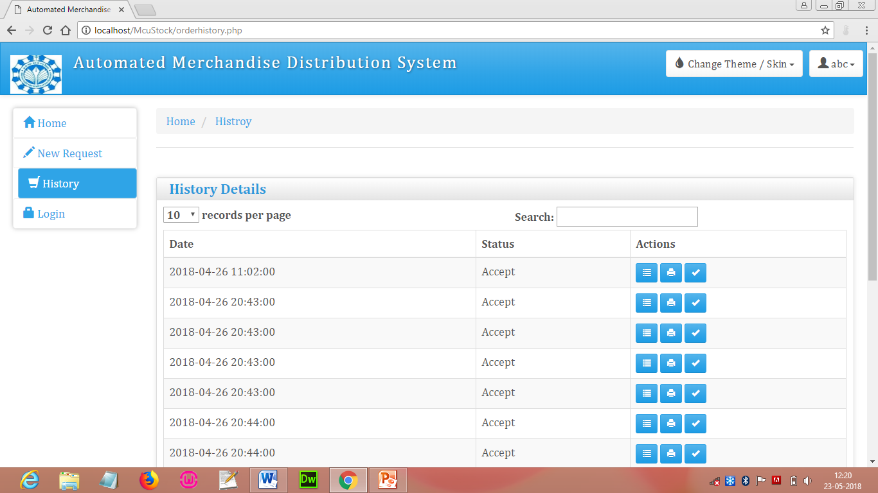

### 7.2 Low Level Diagram-

#### M_dept-

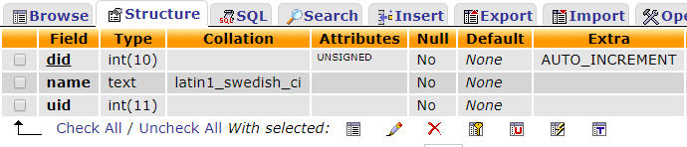

#### M_user-

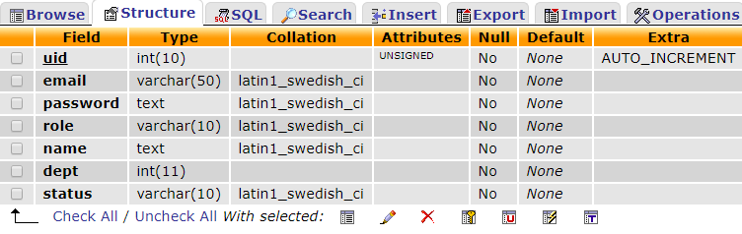

#### M_item-

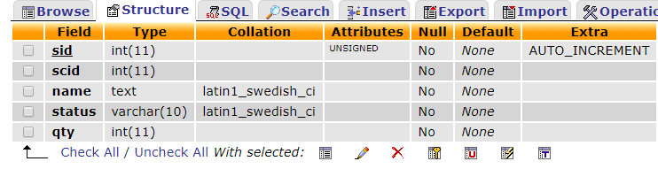

### 

#### M_cat-

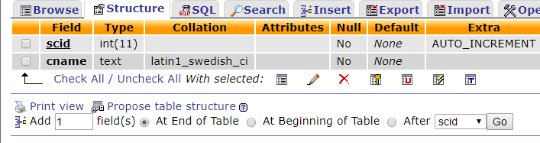

#### M_purchase-

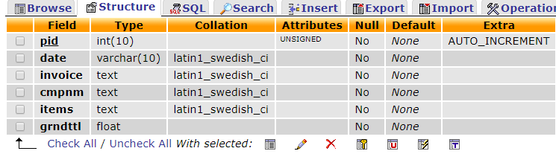

#### M_rqst-

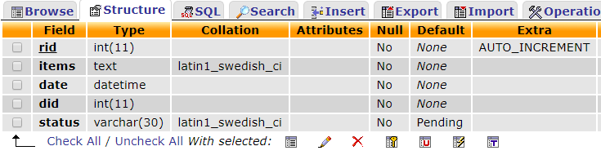

### 7.3 Result Analysis-

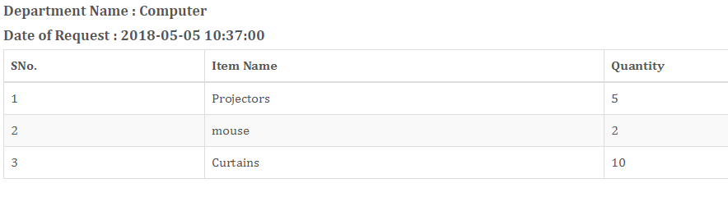

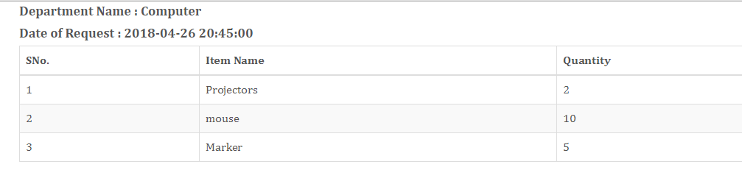

### 7.4 Conclusion-

Finally request generated by Department for merchandise item is view to the Admin.

# Chapter 8

## Future Work

In future work we have to see the items in the merchandise and match it with request of the department if items are less than the request items we have to put him in waiting line with fulfilment of other item which department requested and send department a message or mail for the inconvenience to them about not fulfilling the whole request of that particular department. The items request which are not present in merchandise and delivered later for this Admin can send the message or mail to the department user whose request is not been fulfil.

# 

# Chapter 9

## Conclusion

Automated Merchandise Distribution System is developed to make the existing system automated so as to decrease the work load and consume the time which was as before waste in maintain details about the merchandise items or purchase of that item. Major task of this project is the request management and distribution of merchandise item in between different department of any organisation.

The purpose of the project is to build an application program which means automated work to reduce the manual work for managing the Merchandise of any organisation. As a department request for merchandise they have written all the items in a bill format and then send it to merchandise department we have now insert items directly as we have make that bill automated. If the requested items is not available in the merchandise they event now they get the message or information about the shortage of that particular item. As items come in the merchandise they can send it to department user cannot make request for same items multiple times. Merchandise Handler now have the information about the quantity of each and every item as they were not present in the Merchandise.

This application has good appearance and is very easy to operate. It saves our time and money. This project provides a lot of features to manage in a very well manner. This project contains a lot of advance modules which makes the back end system very powerful.

# Chapter 10

## Company Profile

GIIT is formally known as "Garv Institute of information technology". GIIT is an Information Technology form offering the services in Web Solutions, Product Engineering and Custom Application Development. Its services are spread across the India in various industry verticals including Education, e-Government, Health Care, Legal, Tourism and Hospitality, Construction, Agriculture, Automobile and many more. We possess not only the latest technology gadgets but also the knowledgeable and experience hands to offer customized and cost-effective solutions to their clients.

"***GIIT***" also offers the best Corporate Training Services across the globe. We have revolutionized the way one teaches IT related subjects. We specialize, believe and standby in providing everlasting contribution to the IT industry.

**Our Software Development services:**

1. Custom Software Development and Maintenance
2. Complete Website Solutions
3. Software Migration and Re-engineering

**Our Software Training Services with live project training:**

1. Android
2. PHP & CMS
3. Dot.Net (Asp.net, C#.net, VB.net)
4. Open source technology

**Website Design Services**  
As one of the established ***business website designing company***, eZeon Technologies offer the following companies, small businesses or individual:

* Web site design for companies & individuals
* E-commerce website designing
* Small business website designing
* Website redesign and updates
* Custom web page designing
* Database driven websites designing
* Flash animations & designing
* Corporate Identity design
* Maintenance services
* Internet advice
* Content Management Solutions

**Technologies We Work on**

We are skilled in all the forefront web technologies but we believe it is the ideas that really count. The technologies we generally use for our projects are:

**Designing Tools:** Adobe Photoshop, Illustrator , Coral Draw, and Flash.

**Platforms:** Linux, Windows 7/8/10

**Databases:** My SQL, MS Access, ORACLE, Ms-Sql-Server

**Languages**: PHP, Java Script, Ajax, Android, Dot.Net,jQuery,

**Servers:** Windows and Linux server

For more details about GIIT. Please visit:

**Official website:** [**www.giitbpl.com**](http://www.ezeontech.com/)

# Bibliography

* Along with hints, assistance and partial support from many people, the books that I am referring for my project development are –
* PHP: The Complete Reference, Steven Holzner By Tata McGraw-Hill
* Beginning PHP 5.3,Matt Doyle
* Software Engineering, Rogger S. Pressman.
* System Analysis & Design By Elias M. Awad
* <https://www.w3schools.com/bootstrap/bootstrap_get_started.asp>
* <https://getbootstrap.com/>
* [https://jquery.com](https://jquery.com/)
* <https://www.tutorialspoint.com/jquery/index.htm>
* https://www.tutorialspoint.com/json/json_ajax_example.htm